**PAVesT - PhotoActivated Vesicle tracker manual**

Motivation:

The PhotoActivated Vesicle Tracker PAVesT is written by Rusty Nicovic and uses the .lsm image files from the microscope to count the vesicles in image stacks and performs a cross-correlation of the nearest neighbor distances between the channels.

Installation:

1. Copy the PAVesT.m file into your Matlab library. The script calls some functions and routines which must be provided in addition. Those you can find in the “private” folder, and also have to place into your local Matlab environment.

Usage:

1. 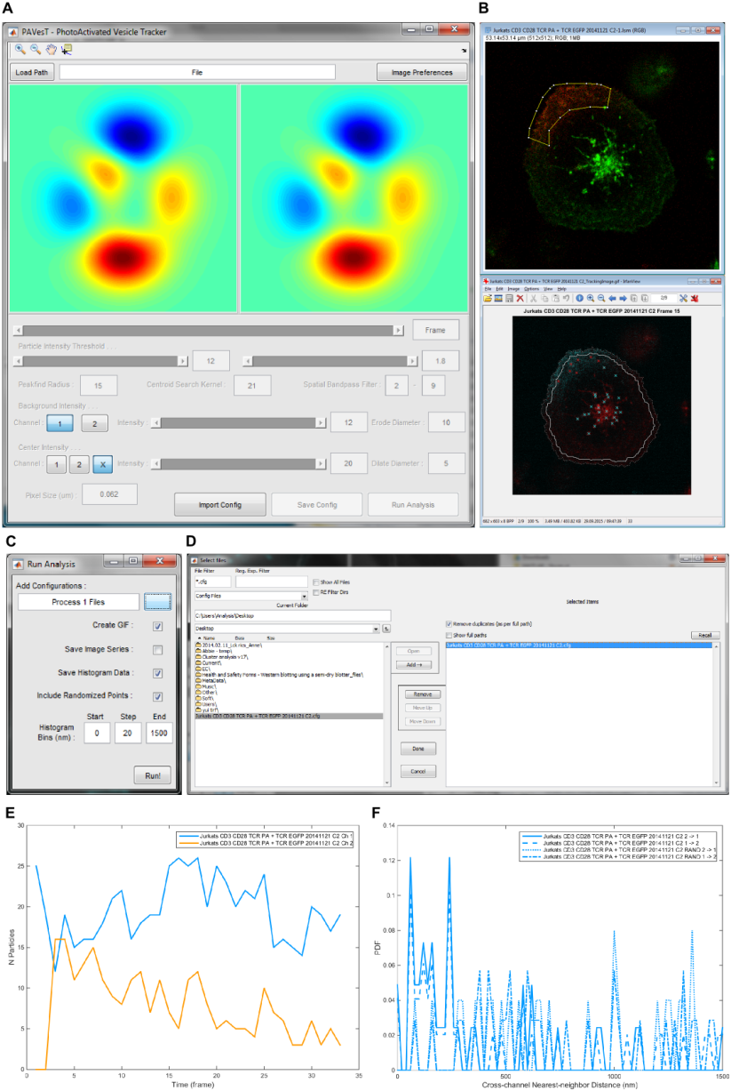Open Matlab, load the PAVesT.m file and click on “run”.

Fig 1 PAVesT.m (a) PAVesT main window. (b) Example input image and processed image with labeled peaks in PAVesT. (c) The “Run Analysis” window. (d) Loading of saved configuration files for batch analysis. (e,f) Results of PAVesT: Vesicle count and cross-correlation of nearest neighbors.

1. PAVesT-window (**Fig 1a**) will open. On the top left side, click “Load Path” to import your image stack. You can adjust the image display parameters (like color and auto-adjustment of the histogram) in the “Image Preferences”.
2. The image stack will be split into two channels and underneath the slide control and Particle Intensity Threshold for each channel is located. These have to be adjusted manually to set the intensity threshold for the particles so that the particles are well separated and well identified from the background (indicated by a little cross for each detected vesicle/particle).
3. Next you have to define the Background Intensity as a cutoff for noise and unspecific signals (see **Fig 1b** for the input image and set parameters for analysis). *Note: You might have to play with both the Particle and Background threshold throughout the stack to find appropriate parameters.*
4. Save the configuration file (.cfg) and perform this step for all the images that have to be analyzed.
5. Lastly, click on the “run analysis” bottom (**Fig 1c**), navigate and select the .cfg files and add them to the analysis pipeline (**Fig 1d**). Then click on “Done” and in the “run analysis” window on “run”. The script will then count and plot the vesicles in each frame of the image and calculate the cross-correlation of nearest neighbors. The results (**Fig 1e,f**) will be saved in the directory, where your .cfg are located (**Fig 2**).

*Note: The “SummaryBarPlot_XX_InOutImg.png” will be saved in your Matlab home directory.*

1. The “SummaryBarPlot_XX_InOutImg.txt” contains the vesicle count results of both channels per frame and the “SummaryBarPlot_01_Data.txt” stores the numbers of the cross-correlation calculation. In addition, a .gif file of the image stack with labeled found peaks will be saved.
2. Transfer the numbers to Prism and make nice graphs.

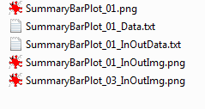

**Fig 2 Output files.** Output files after PAVesT run